**Tool to correct the river network**

Version 0.9 PB 4/3/2024

Version 0.91 PB 28/11/2024

**Folder: Tool_to_correct_...**

But might be faster if you copy the whole folder to your local drive.

The cor_Danube_1min1.mxd has stored relative pathnames – so it should find the correct shape and raster files (but you have to change the pathnames in the model builder)

1. **Main files and folders**

cor_Danube_1min1.mxd: ArcGIS file

ldd_points_danube.shp: Shape with arrows for directions of the river network

Correct_LDD.tbx: Toolbox for ArcGIS to create shape and rasters from point shape

LDD_corrected2: Folder with results (shape and rasters)

Shapes: Folder with shape files e.g. EU_hydro river network

Raster: Raster .tif files e.g. ldd.tif (river network), upstream area, cellarea

1. **Work with the tool**

**2.1 Create point shape file from existing rivernetwork raster (ldd.tif)**

* load ../TOOL_to_correct_Danube/Correct_LDD.tbx into the toolbox
  + open ArcToolbox, right click on ArcToolbox -> Add toolbox

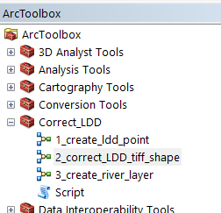

* run 1_create_ldd_point
  + ArcGis is not overwriting files by default. If you want to overwrite your files you have to run: Correct_LDD/Script first
  + You might have to change the path. ArcGis has a problem with relative paths.  
    You have to change the last part of the path (or overwrite files) 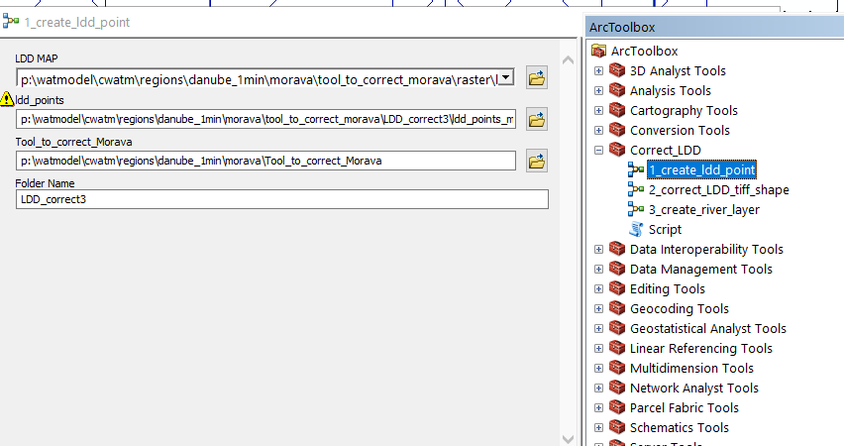
* This will create a point shape of all grid points:

e.g. LDD_correct3/ ldd_points_morava.shp

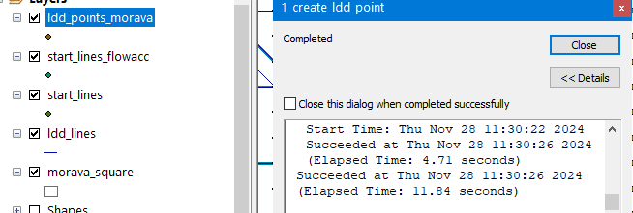

* if you created a ldd_points_...
  + move ldd_points_.. to HighReszoomIn
  + import Symbology
  + 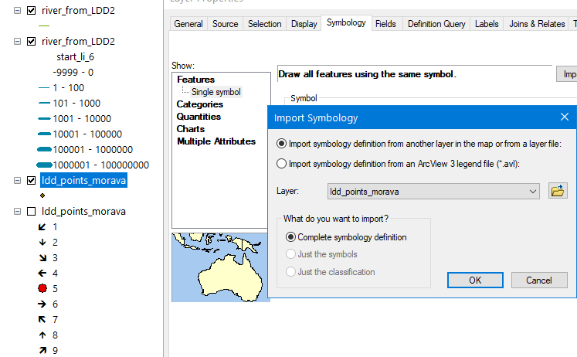

You now have a point shape file with direction indicators of each cell

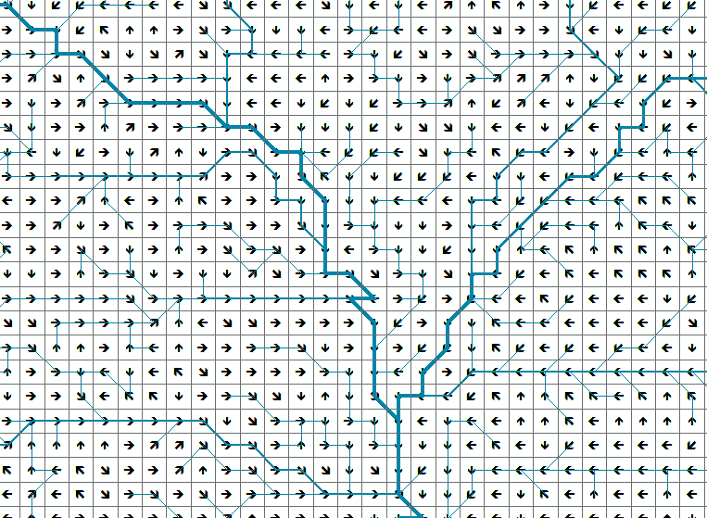

**2.2 Changing the river direction in the shape ldd_points_danube**

* right click ldd_points_danube -> selection -> Make this the only selectable layer

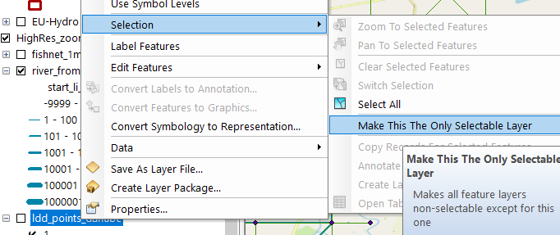

* customize -> toolbars -> editor
* Editor -> start editing _> ldd_points_danube

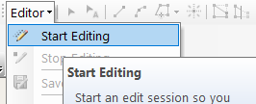

* select single point -> open attribute table

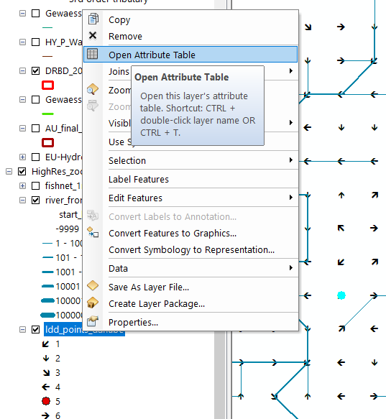

* change grid_code (eg. from 1 (SW) to 2 (South)  
   The direction is the same as the extended keyboard  
  7 8 9  
  4 6  
  1 2 3  
  and the 5 is indicating a sink (last point of a basin)  
  After selecting the next - check if the arrow point in the right direction

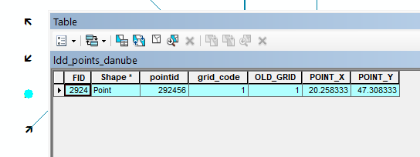

* select next point (arrow) and change. Repeat and repeat and repeat
* Editor -> save edits (will take some time)

Result:

A corrected point shape file with direction indicators

Remarks:

Best check your river network with other data:

(here on the right: OpenStreetMap and EU_Hydro river network)

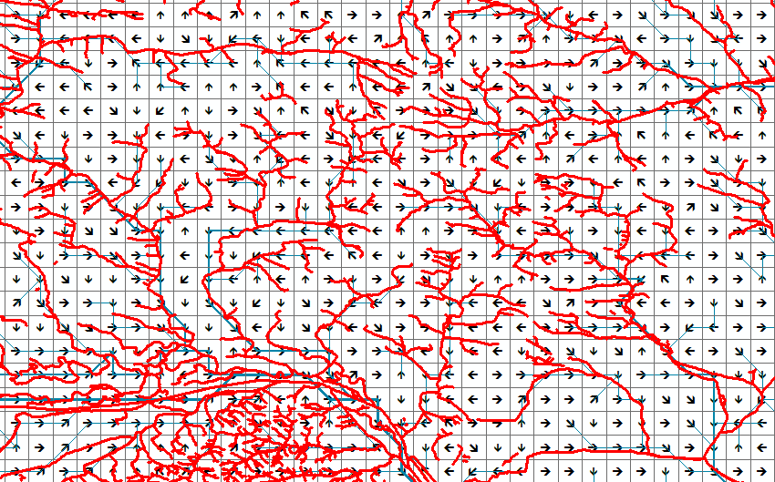Even better: Country data (Gewaessernetz Austria)

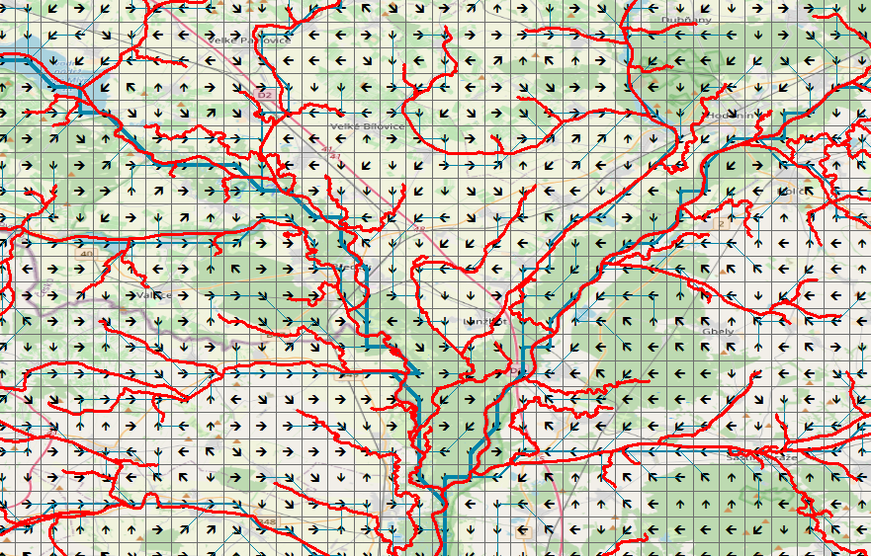

**2.3 Creating a new raster river network (LDD – local drainage direction)**

* run 2_correct_LDD_tiff_shape
  + ArcGis is not overwriting files by default. If you want to overwrite your files you have to run: Correct_LDD/Script first
  + You might have to change the path. ArcGis has a problem with relative paths.  
    You have to change the last part of the path (or overwrite files)

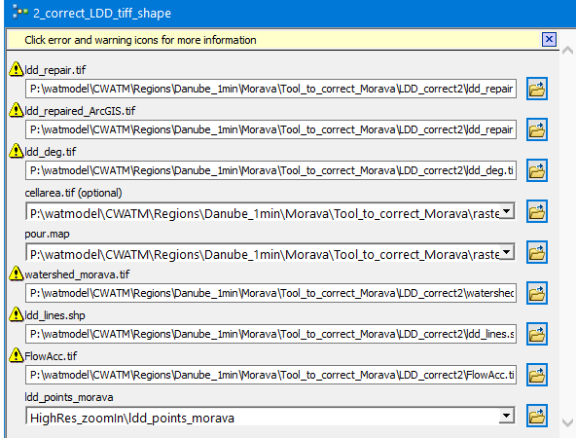

* + In case you want to permanently change the path names you have to edit the model build (right click on 2_correct_LDD_tiff_shape and Edit)

**Results:**

* ldd_repair.tif correct LDD -> used for CWatM
* ldd_repaired_ArcGIS.tif LDD with ArcGis convention of neighbor points
* ldd_deg.tif: LDD with degree as conventionneighbor points   
  e.g. ldd _repair value 7: is pointing to northeast -> ArcGIS: 32 -> degree: 315
* watershed_morava.tif -> watershed of the basin: all points included in the watershed (here you can see, if you excluded some gridcell, by an accidently circular round)
* ldd_lines.shp : connection lines of grid points
* FlowAcc.tif: upstream area calculated with ArcGis

**2.4 Creating a line shape which shows the direction of the river network**

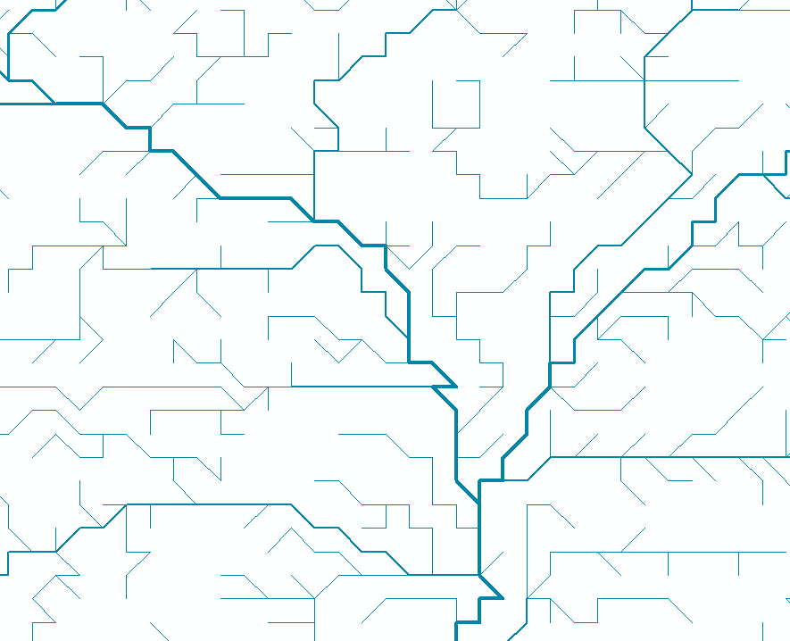

* run 3_create_river_layer
  + change the pathnames
  + the shape file: ldd_lines.shp has to be loaded
* if you created a new river_from_LDD2
  + move river_from_LDD2 to HighReszoomIn
  + import Symbology
  + 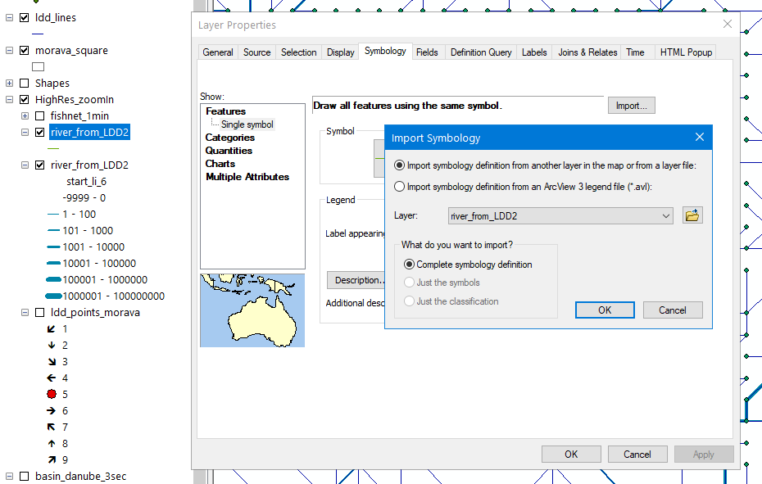

1. **remarks:**
2. try to avoid number <0 and number >9. This will crash the network.

If you are unsure, that you put a e.g. 23 accidently in:  
sort ldd_points_danube biggest first then lowest first to see if you put in a number >9 or <1

1. try to avoid circular round, e.g. a grid cell is pointing to another gridcell pointing back to the original gridcell (can be bigger loops, too)